**EIT Health start-ups raise up to EUR 4 million funding**

**News 28/11/2019**

[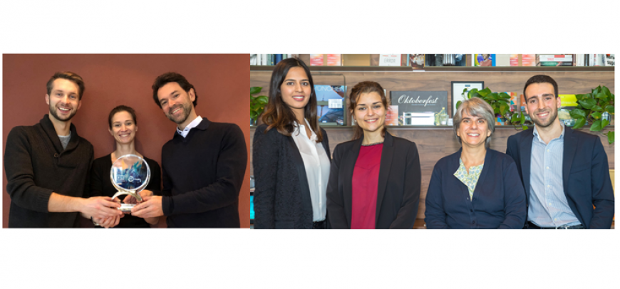](https://eit.europa.eu/sites/default/files/3eit_health_start-ups_with_up.png)

**After months of training and competition, two**[**EIT Health**](https://www.eithealth.eu/)**-supported teams have incorporated as start-ups and will receive up to EUR 2 million each over two years through**[**EIT Health's Wild Card programme**](https://www.eithealth.eu/wild-card-projects)**.**

Newly created start-ups, iLoF and Pipra, will also receive access to EIT Health's business mentors, as well as other academic and commercial support from the network, to develop and commercialize their solutions. The teams were chosen from among 70 individuals and teams who applied to join the EIT Health Wild Card 2019 programme by providing transformative solutions to one of two challenge areas: Mental and Brain Health and Digital Biomarkers. Applications were whittled down to 35 for the competitive 'Hackathon' phase in April, after which six final teams entered a 10-week business validation phase that culminated in a final pitching event on 17 July 2019.

**About the new start-ups**

According to the European Brain Council, as many as one in three of us will develop a brain disorder at some point in life. Detecting functional decline, establishing the means for early intervention and preventative measures, and developing a gold-standard approach for the management of early-stage mental and brain health issues are therefore critical challenges. Both iLoF and Pipra help address these challenges.[iLoF](https://www.eithealth.eu/ilof) was created by Dr Joana Paiva, Professor Paula Sampaio, Dr Mehak Mumtaz and Luis Valente. After more than 14 years and 400 major Alzheimer's trials failed, there is a change needed in the approach to clinical trials. About 90% of initially enrolled patients leave trials due to invasive, inconvenient screening, causing the development of potentially effective drugs to be abandoned. Using non-invasive, portable, inexpensive photonics and Artificial Intelligence system test, iLoF will transform patients' experience and make clinical trials convenient and patient-centric. By saving 40% of the total costs and 70% of the time spent on screening and stratifying Alzheimer's patients for clinical trials, iLoF hopes to become an enabler for finding the cure for the disease.

[Pipra](https://www.eithealth.eu/en_US/pipra) AG was created by serial entrepreneurs John Klepper, Nayeli Schmutz, MD, and Benjamin Dodsworth, PhD. The company is developing a digital application to assess the risk for a patient presenting cognitive disorders after surgery. More than 25% of patients over 60 years old are affected by a postoperative cognitive decline (POCD) and postoperative delirium (POD). These surgery complications lead to patient disorientation, confusion, behavioural changes, and related increased hospital stay and costs. Pipra’s data-driven and AI-based application will allow clinicians to inform patients about their individual risk for such complications and adopt personalized pre- and postoperative measures to prevent such surgery-related outcomes.

**'From strength to strength'**

*The Wild Card programme has gone from strength to strength, and the quality of applications we received this year is a testament to that. Our experience tells us that while there are many great healthcare ideas waiting to be unlocked, the real difficulty is finding the right people and working environments to actually deliver them to the market. Wild Card is the missing link in this process: we provide a framework in which to foster, test and refine these ideas, and the supports and funding necessary to commercialise them.*

*Jan-Philipp Beck, CEO of EIT Health*

'On behalf of everyone at EIT Health, I’d like to congratulate Pipra and iLoF, and thank everyone who participated and entered for their hard work and dedication. In reality, every team has won something from this experience. We expect to see several of our finalists go on and achieve success, bolstered by the tools they have gained from the programme,' said Jan-Philipp Beck, CEO of EIT Health.

**2020 Wild Card Challenges revealed**

Next year's Wild Card Challenges have already been chosen and applications will open soon for innovators who want to address these topics:

**Women’s Health**: How to improve prediction, diagnosis and treatment to advance women’s health outcomes?

**Digital Therapeutics**: How to harness the power of digital solutions to prevent, manage and treat medical conditions or disease?

**About the Wild Card programme**

Through the [Wild Card Programme](https://www.eithealth.eu/wild-card-projects), EIT Health creates new business ventures from teams and individuals with big ideas – people who are not afraid to defy convention, take a risk and with EIT help, create products and services that will change people’s lives.